**Programming for Problem Solving**

**WEEK-1**

**LONG DESCRIPTIVE QUESTION**

**1. Write C Program to check whether a Number is even or odd?**

**ANS:**

#include <stdio.h>

int main()

{

int num;

printf("Enter an integer: ");

scanf("%d", &num);

if(num % 2 == 0)

printf("%d is even.", num);

else

printf("%d is odd.", num);

return 0;

}

**SAMPLE OUTPUT:**

Enter an integer: 23

23 is odd.

**2. Which symbol is used for decision making in flowchart?**

A ***diamond*** represents a decision or branching point. Lines coming out from the diamond indicates different possible situations, leading to different sub-processes

**3. Write an algorithm and draw the flowchart to compute the electricity charges for the consumer as per the following slab:**

**Slab rate:**

**Consumed electricity Units from 1 to 199 – Charges is 1.20**

**Consumed electricity Units from 200 to 399 – Charges is 1.50**

**Consumed electricity Units from 400 to 599 – Charges is 1.80**

**Consumed electricity Units from 600 and above – Charges is 2**

**If the charges exceed Rs 500 then an extra charge of 15% will be charged provided minimum bill should be Rs100**

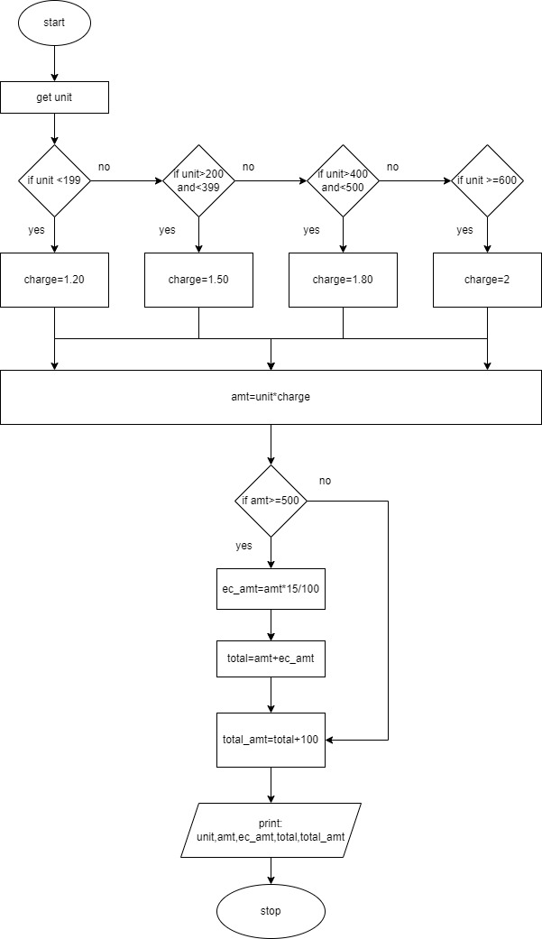

**Algorithm**

* Step-1: Start
* Step-2: Read the unit consumed
* Step-3: If the unit is less than 199 then charge 1.20 per unit
* Step-4: If the unit is greater than 200 and less than 399, then charge 1.50 per unit
* Step-5: If the unit is greater than 400 and less than 500 , then charge 1.80 per unit
* Step-6: If the unit is greater than 600 and above, then charge 1.80 per unit
* Step-7: Calculate the amount by unit* charge
* Step-8: If in case the amount is greater than 500, then an extra charge of 15% of the total amount is charge total = amount + extra charge
* Step-9: Addition of Rs.100 as a minimum charge for all customer to the total amount
* Step-10: Print the unit consumed amount, extra charge, total amount + 100
* Step-11: Stop